The Gilbertson Gazette – Week 20
Mrs. Gilbertson’s Class
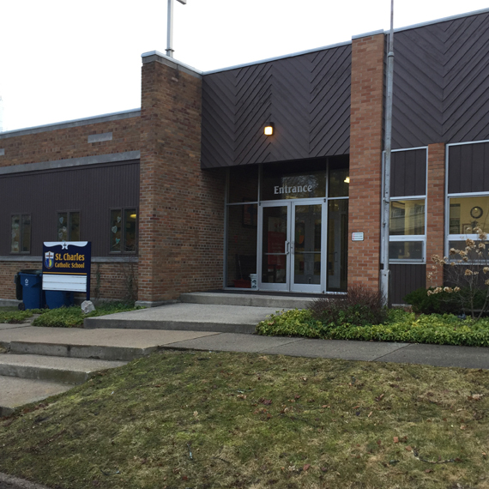

Upcoming Events

January 21
March for Life

January 24
Conferences Begin

January 28
8th Grade Raffle Preview
“Go forth and set the world on fire.”
-St. Ignatius of Loyola

7th and 8th Grade Room 8
Email: jgilbertson@saintscjm.com
Telephone: 616-754-3416 ext. 148
Website: https://saintscjm.com/school
Dear Families-
Conference time is upon us once more. St. Charles will be conducting conferences virtually January 24 – February 11. Today, I sent an email to each middle school family with the dates and times I am available for conferences. I requested that each family’s top three schedule choices be sent to me by Sunday, 1/23/22. Please look for the email and get back to me with a date and time that will work for you as soon as possible. Your child does not need to attend the conference. We will be discussing 2nd marking period performance and Winter MAPS testing. I look forward to hearing from you soon.
Blessings,
-Jessica Gilbertson
- MAPS Testing:
The students were able to stay on track and finish their MAPS math testing on schedule. Time permitting, we will attempt to finish the language arts test this coming week.
- Just a Reminder:
The students seemed to have a great time at farm school on Tuesday and Wednesday. Sledding was clearly a highlight. The students focused on Michigan mammals. The kids learned all about habitats, tracking, food sources, using compasses, etc. They were two very cold very busy days. I know we are looking forward to going back going the spring. A very special thank you to Mrs. Platte and Mr. Peacock for driving and chaperoning.
Coming up:
-English Language Arts (ELA) 7/8– Grammar focus Lessons #85(Gerunds and Gerund Phrases) #89 (Independent and Dependent Clauses). Novel study of Treasure Island by Robert L. Stevenson. This Novel will close at the end of January 2022.
-Physical Science 7/8– The continue Chapter 3: Forces in Fluid. Expect an assessment early next week.
-Social Studies 7/8 – Continue Chapter 7: Launching a Nation this week. We will continue working on this chapter this coming week.
-Theology 7/8 –Begin the second half of Unit 2: Lesson 8 -15.

- ****Earth Science 6 – We finished Chapter 3: Erosion and Deposition. Students can expect and assessment on Tuesday.*****

