The Gilbertson Gazette – Week 8
Mrs. Gilbertson’s Class
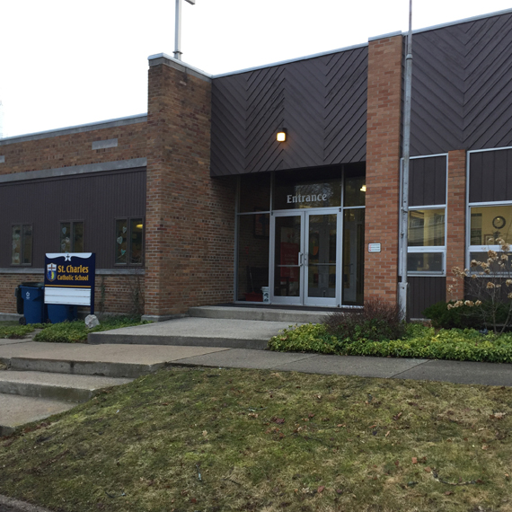

Upcoming Events

October 5
Interact Meeting 7AM Grades 6-8
Parent Teacher Conferences

October 6
Theology Quiz: Lessons 5&6

Important Announcement
“Go forth and set the world on fire.”
-St. Ignatius of Loyola

7th and 8th Grade Room 8
Email: jgilbertson@saintscjm.com
Telephone: 616-754-3416 ext. 148
Website: https://saintscjm.com/school
Middle School Families-
It was wonderful to meet with so many of you this week at conferences. Being face-to-face to discuss the success of your children is such a gift this year. If there are still 5th and 6th grade families wishing to schedule a conference, feel free to contact me.
I pray you all have safe and relaxing weekend.
Blessings-
-Mrs. “G”
- Reminder: Mass at 8:00 Wednesday Mornings-
Participating in the liturgy with our greater faith community first thing in the morning is such a blessing. Parents are welcome to attend Mass with us. It would be wonderful to share the experience with you. We hope to see you there.

- Sneak Peek:
Coming up this week:
-Religion 7/8 – Monday: Continue Unit 1– Exploring Personal Growth (Lesson 6 and 7, and Quiz over Lessons 5/6 on Wednesday).

-English Language Arts (ELA) 7/8– Grammar focus Lessons 26 (possessive nouns)-25 (direct objects). Continue work on essay contest essays: “My Personal Michigan Hero” with concept mapping and five paragraph outlines.

-Science 8– Begin Chapter 3: Elements and the Periodic Table

-Social Studies 8 – Chapter 3: The English Colonies

**Earth Science 5/6 – Continue Chapter 2: Mineral and Rocks: This coming weekLesson 4: Sedimentary Rock, Lesson 5: Metamorphic Rock, and Lesson 6: The Rock Cycle.

